# Create Daily Cycle Status Report Procedure

Service Level Management

**Purpose**

This document details the steps for the SLM group to follow when updating and distributing the Daily Cycle Status Report. The Daily Cycle Status report is a point in time, where that time is the completion of each individual Service SLA for the indicated cycle date. For those days in which any SLA has not completed prior to the publishing of the report, updates will be reflected in the [Cycle Status Report Link](http://docs.jackson.local/it/sites/rs/Daily%20Reporting/2020/Cycle%20Status%20Report/05%20May/05202020%20Morning%20Cycle%20Report.pdf?d=wee1ace971dfe462b80018f85afdec619) on an hourly basis until all SLAs have completed. Research may be done later that could change/correct the details for any missed SLAs. This changed/corrected detail information is available in the monthly SLA report which supersedes the data in the Daily Cycle Status Report.

The last section of the report is Cycle Completion. This reflects all processing that has completed for each application/system listed for the indicated cycle date. This does not represent any specific Service SLA but does include completion of all individual Service SLAs, backups, print jobs, and reorgs, etc. When a cycle misses its SLA, impact assessment will be done to determine if further action is needed. Since this encompasses the entire processing of cycle, the completion may occur late in the day, see the table below for the schedule of the days that will be reported in each Cycle Status Report email. Completion times for the most recent cycle date will be reflected in the [Cycle Status Report Link](http://docs.jackson.local/it/sites/rs/Daily%20Reporting/2020/Cycle%20Status%20Report/05%20May/05202020%20Morning%20Cycle%20Report.pdf?d=wee1ace971dfe462b80018f85afdec619) on an hourly basis until all cycle processing has completed.

**Report Run Times**

This process is to be run multiple times a day on Monday – Friday to capture cycle statuses throughout the day. On Mondays, all information should be able to be captured with the first run of the day. Below is the timeline to populate and publish the report. These times should be followed as closely as possible to keep consistency. Continue throughout the day until all items have been completed for a given day.

* **Monday thru Friday** – Publish the report by 08:00
* **Tuesday thru Friday** – Based on the ETA’s that are reported, the report should be run and published within a half hour after the next ETA.

*(Example: Cyber onlines reported at 08:00 with an ETA of 09:30 or 09:45. The next run of the report should be published by 10:00).*

Continue to check the P99YE* jobs every hour throughout the day and when there are any status changes run the Append until all completion times are populated for **Application Cycle Completion** (P99YE* jobs).

|  |  |
| --- | --- |
| **Reporting Day** | **Cycle Days being reported** |
| Monday | Prior Thursday and Friday |
| Tuesday | No cycle will be reported |
| Wednesday | Monday |
| Thursday | Tuesday |
| Friday | Wednesday |

**Related Policy**

* [IT Service Management Policy](https://sharepoint.jackson.com/sites/itsmsd/servicelevelmanagement/Shared%20Documents/Pre%20December%202019/SLM%20Documents/Policy%2C%20Process%2C%20Procedures/SLM_Service%20Level%20Management%20Process.doc?d=wa1eaba53e1dc4b30abda2a0886981cc9)

**Audience**

The following groups are responsible for adhering to this document:

* Service Level Management

**Procedure**

|  |  |
| --- | --- |
| Step | Action |
|  | **Review emails in the Service Level Management in-box. If any of these emails are missing investigate why.**   * Monday – Friday there will an email for P99VOCFD - Policy Values to Web & Book of Business to Web. * Monday – Friday there will be emails for “all clear” and one will include the cycle release time. * Anytime an SLA is missed there will be emails from the Data Center containing information regarding the ETA, the cause, and who worked on it. |
|  | **Populate the Cycle Status Database using Microsoft Access**  The first time you start Microsoft Access, you will need to select File > Open, then  O:\share\Service Delivery\Service Level Management\SLA Reporting\Reporting\Report Generators (Note: After you have done this once, you will be able to pick the database from the OPEN RECENT DATABASE menu on the right side of the screen.) |
|  | **Append Job Data**   1. Double-click the **Append_Job_Data_for_Missed_SLA** selection 2. You will receive the following dialogue box to enter the date:      1. Enter the cycle date that you want to report on (in the mm/dd/yyyy format) and click OK. |
|  | When prompted to log in to DBP2, use your mainframe credentials (see sample below). Once you enter your mainframe user ID and password, click OK.     1. You will receive a message that you are about to append rows, click “Yes”      1. You will receive a message that Microsoft access can’t append all the records, this is due to 2 P99NFF7D jobs being required, click “Yes”      1. For Mondays there is an additional run. See **Step 7**, then return to **Step 5**. |
|  | Review the table *Job_Data_For_Date_Of_Cycle* for any jobs that do not have end times. There can be 2 reasons:   * The jobs have not run yet * The VA_SMFJOB table on the mainframe has not been uploaded with the data yet. P99FR11D runs at the top of every hour 24/7 to pull jobs that have completed in the previous hour  1. If any jobs do not have end times you will need to look them up in TWS to acquire the end time. 2. Once you are logged into JNL1 (Mainframe):    1. Type **=O.T** on the “Option” line to access TWS.      * 1. Type **5.3** at the “Option” prompt.      * 1. Type in the job name at the “Jobname” prompt.      * 1. Verify that there is a Job ID for the input arrival date of the cycle you are reporting on to ensure it actually ran. If there is no job id that means the job did not/has not run. Investigation will need to be done except for the P99YE* jobs which have at 11:59 PM SLA Time.      * 1. If there is a job ID, hit F11. This will show the End time of the job.      1. Go back to the ACCESS database 2. Enter the “Actual” end time into the table “Job_Data_For_Date_Of_Cycle” in the cell END_TS_AsString 3. Copy that cell and paste it in END_TS cell.  | **Job_Data_For_Date_Of_Cycle** | | | | | | | | | | --- | --- | --- | --- | --- | --- | --- | --- | --- | | **Cycle_D** | **Job_Category_Seq** | **Job_Name_X** | **END_TS** | **END_TS_AsString** | **Report_TS** | **Job_Category_Desc** | **SLA_TS** | **App_Desc** | | 6/8/2017 | 4 | P99DL07D | 6/9/2017 4:31:00 AM | 06/09/2017 04:31 | 6/9/2017 7:09:00 AM | Lawson Report | 06/09/2017 7:00 | Financial | |
|  | **Updating Mid-Day Runs (P99YM90D and P99NFF7D)**   1. Bring up P99YM90D in TWS (O.T 5.3) and verify there is a job number.      1. PF11 to see the Actual End Time      1. Go back to the ACCESS database and open the table “Job_Data_For_Date_Of_Cycle”    1. Find P99YM90D row 2. Enter the “Actual” end time into the table “Job_Data_For_Date_Of_Cycle” in the cell END_TS_AsString    1. Copy that cell and paste it in END_TS cell  | **Job_Data_For_Date_Of_Cycle** | | | | | | | | | | --- | --- | --- | --- | --- | --- | --- | --- | --- | | **Cycle_D** | **Job_Category_Seq** | **Job_Name_X** | **END_TS** | **END_TS_AsString** | **Report_TS** | **Job_Category_Desc** | **SLA_TS** | **App_Desc** | | 6/8/2017 | 4 | P99YM90D | 6/9/2017 4:31:00 AM | 06/08/2017 12:31 | 6/8/2017 12::00 PM | Lawson Report | 06/08/2017 13:00 | Financial |  * 1. Change the date in the SLA_TS column to match the cycle date and make sure the time is 13:00  1. Find P99NFF7D row 2. Left click in the grey cell in front of the date to select the row      1. Right click in the grey cell and select “Copy” 2. Right click in the grey cell again and select “New Record”    1. This will insert a blank line at the bottom of the table    2. Right click in the grey square in front of the blank line and select “Paste”    3. Now put any time in the SLA_ETA_X (required to save the record and will be deleted later)    4. Change the date in the SLA_TS column to match the cycle date and the time to be 13:00 3. Bring up P99NFF7D in TWS (O.T 5.3) and verify there is a job ID      1. PF11 to see the Actual End Time      1. Go back to the ACCESS database and open the table “Job_Data_For_Date_Of_Cycle” 2. Enter the “Actual” end time into the table “Job_Data_For_Date_Of_Cycle” in the cell END_TS_AsString    1. Copy that cell and paste it in END_TS cell    2. Close the screen and re-open it    3. Verify there are 2 P99NFF7D jobs and one has the prior date with 13:00 under SLA_TS column.    4. Delete the time (13:00) you put under the SLA_ETA_X column    5. Close the table “Job_Data_For_Date_Of_Cycle” and go to step 8 |
|  | **Monday only!** Tuesday through Friday, skip this step.  On Mondays the e-Feeds jobs will need to be included on the report. These jobs are part of Friday night’s cycle, but they do not run until early Monday morning.   1. Repeat Step 4 but use Sunday’s date as the “Cycle Date”. 2. After completing step 4, open the table “Job_Data_For_Date_of_Cycle”      1. Remove all the rows for Sunday’s date except the following jobs (instructions in step 6):  * P99NFXBD (E-Feeds) * P99NFXCD (E-Feeds) * P99NFXQD (E-Feeds) * P99NFXRD (E-Feeds) * P99NFXSD (E-Feeds) * P99NFXVD (E-Feeds) * P99JX46D (E-Feeds) * P99NFF7D (E-Feeds) * P99YM90D (E-Feeds) * P99YM92D (Operational Checks) * P99PN03D (JDS Reporting)  1. Update the Cycle Date column for the e-Feeds jobs to be Friday’s cycle date. This is required to show the jobs on the current report.      1. Close the table and return to step 5. |
|  | **Run Report – See an example of the report in** **Appendix A**   1. Double-click on 2. Enter the cycle date and click OK.   .   1. You will see the report displayed: |
|  | **Review Report – If the colors are not being shown correctly see** **Appendix C** **to fix.**   1. Review the JTS_Morning_Report for any entries that missed their deadline times. Deadline statuses will be indicated by colors shown in the Status Legend. **If all services targets have been met (this does not include end of cycle), proceed to Step 12.** 2. If there are any outstanding or missed service targets, research the cause.    1. If an ETA is in the future, set email reminder to run at that ETA.    2. If a Service Target is missed and job is incomplete, see the Data Center email and update the cells in the table “Job_Data_For_Date_of_Cycle”: 3. SLA_ETA_X (and set email reminder to run at that ETA) 4. SLA_Reason_X 5. SLA_Impact – see table “SLA Impact” for general description and modify it to clearly identify the impact for that day.    1. If a Service Target is missed and job is complete, see the Data Center email and update the cells in the table “Job_Data_For_Date_of_Cycle”: 6. SLA_Reason_X 7. SLA_Impact– see table “SLA Impact” for general description and modify it to clearly identify the impact for that day.   ***Note:*** *For Holiday Exception times, see* ***Appendix D.*** |
|  | Run the JTS_Morning_Report again by repeating Step 8. |
|  | Review the report to make sure that all necessary fields are populated, based on the status of the Events.   1. If all the fields are populated, go to Step 12. 2. If more updates are needed, go back to Step 9, and enter the missing information. |
|  | **Export Report**   1. With the fully populated report still open, click on the External Data tab. 2. Click on the PDF or XPS selection shown in the circle above, which will bring up a SAVE AS box 3. Save the report as a PDF in  \\jacksonnational.com\SHARE\HQ\vol3\share\Service Delivery\Service Level Management\SLA Reporting\Reporting \YYYY\Cycle Status Report\Month. Name it “MMDDYYYY Morning Cycle Report” and click Publish.      1. The screen below will appear. Click Close.      1. The report will open in a new window. |
|  | **Publish the Report to SharePoint**   1. Bring up “[Daily Reporting](http://docs.jackson.local/it/sites/rs/_layouts/15/start.aspx#/Daily%20Reporting/Forms/current.aspx)” 2. Click on the current year folder 3. Click on “Morning Cycle Status”      1. Click on the current month folder 2. Click “Upload”      1. Upload the report that was saved at O:\share\Service Delivery\Service Level Management\SLA Reporting\Reporting\YYYY\Cycle Status Report\Month\ MMDDYYYY Morning Cycle Report.pdf |
|  | **Create Morning Cycle Status Email – see email example in** **Appendix B**   1. In the Production Support email box folder “Morning Cycle Status Report”, select one of the prior emails 2. Click on “Reply All” in the Outlook taskbar. 3. The “From: and “To” fields should already be filled in. Update the mm/dd/yyyy in the Subject field to the cycle date you ran the report for. 4. Delete the screen shots from the prior email (make sure to change the “mm/dd/yyyy Cycle Completion” date) 5. Update the “Cycle was released at HH:MM” with the time from the Data Center “all clear” email found in **Step** **1** of this procedure. 6. Go to the first page of the report.    1. Set the size to 75% 7. Click on edit and the tool bar and select Take a Snapshot or use the Snipping Tool.      1. Hover over the screen and a + will appear (dotted line not solid)    1. Starting in the upper left corner of the whitespace of the report, hold down the left mouse button and pull down to the lower right corner of the whitespace of the report.   ***Note: Do not include page numbers in your snapshot. Also, do not include headers other than on the first page. See*** ***Appendix A*** ***to view an example of how the pasted report will look.***  When you release the mouse button, a snapshot will be taken of the page.     1. Go to the email and click after the text      1. Select paste from the tool bar and select special, bit map.      1. Click okay. Repeat for each screen until you have all the data for that date pasted into the email. **Do not** **paste** the current Cycle Completion Section. 2. Go to the prior day’s final PDF and take a snapshot of the Cycle Completion section 4. Go into SharePoint and click on the **…** to copy the link to today’s document      1. Right click on the link in the email      1. Select Edit Hyperlink      1. Paste the link you copied from SharePoint into **both** hyperlinks.   ***Note:*** *There is one located in the top portion of the email and another near the “Cycle Completion” section.*   1. Verify everything is correct (including the hyperlinks open the correct report) and then send email. |
|  | **Load all pertaining information to SharePoint**   1. The Cycle Status Report email that was sent (“Cycle Status Email” folder). 2. Any emails pertaining to missed SLAs (“Reasons for Missed SLA” folder). 3. The All clear emails (“Cycle Release Email” folder). 4. Policy Values for P99VOCFD (“Policy Data Upload Email” folder). |
|  | **Updating Today’s Report**  In addition to SLAs that missed their deadlines, there may be SLAs that fall after the initial run of this report on a given day, which will show without highlight on the report. Both situations will require updates and the regeneration of the report on an hourly basis until all SLAs have been completed.  Follow these steps to regenerate the report with updated information.   1. Review the *JTS_Morning_Report* for outstanding jobs that have statuses that have changed since the last run. 2. Look for missed SLA items that have completed since the last run of the report. 3. Review the current ETA times for any missed SLAs that have not completed yet and determine if the times need to be pushed back. Coordinate with the Data Center. 4. If the job is completed, enter the date and time in the table “Job_Data_For_Date_of_Cycle”, cell END_TS_AsString    1. Copy that cell and paste it in END_TS cell 5. If a missed SLA is still not complete, update the ETA to a new time if warranted. |
|  | **Rerunning and Republishing Today’s Report**   1. Repeat Step 8 to run the report and review it for correctness. 2. Repeat Step 12 but rename the previous report as a **version** **2** using this path. O:\share\Service Delivery\Service Level Management\SLA Reporting\Reporting\YYYY\Cycle Status Report\Month\ MMDDYYYY Morning Cycle Report.pdf 3. The same name must be used and published to SharePoint, so updates are visible using the original link sent out as part of Step 14.    1. Go to the SharePoint site and upload the most recent version of today’s report.    2. Click upload      * 1. Click browse      1. Select the file you just saved, click open and hit ok. 2. A second box will pop up asking you to SAVE, hit save |
|  | Repeat Step 16 and 17 until all statuses are complete, incrementing the version # as instructed in Step 16 each time. |

# Appendix A – Report Example

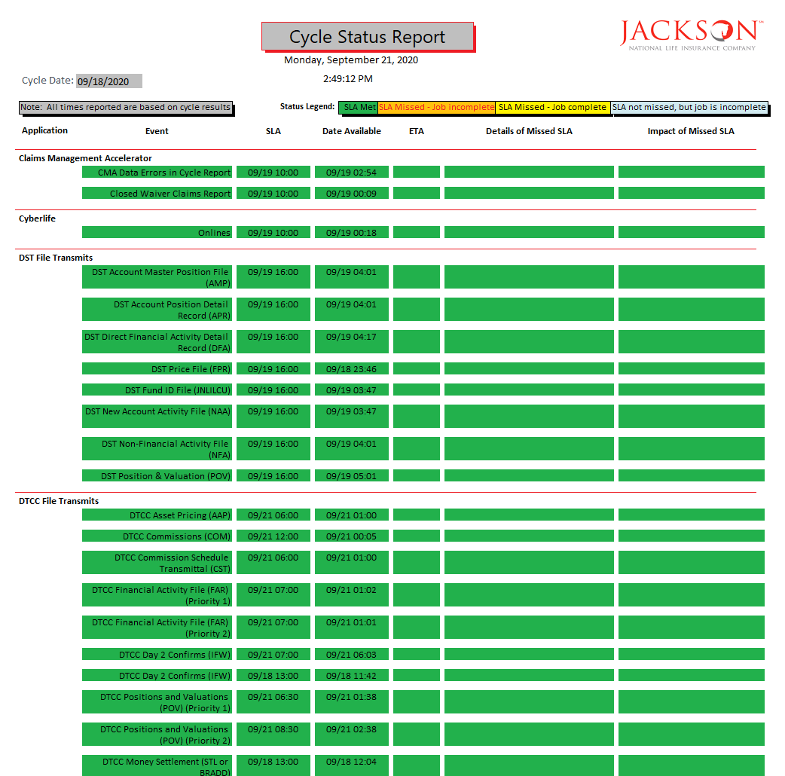

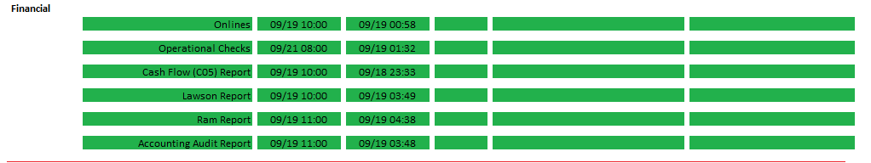

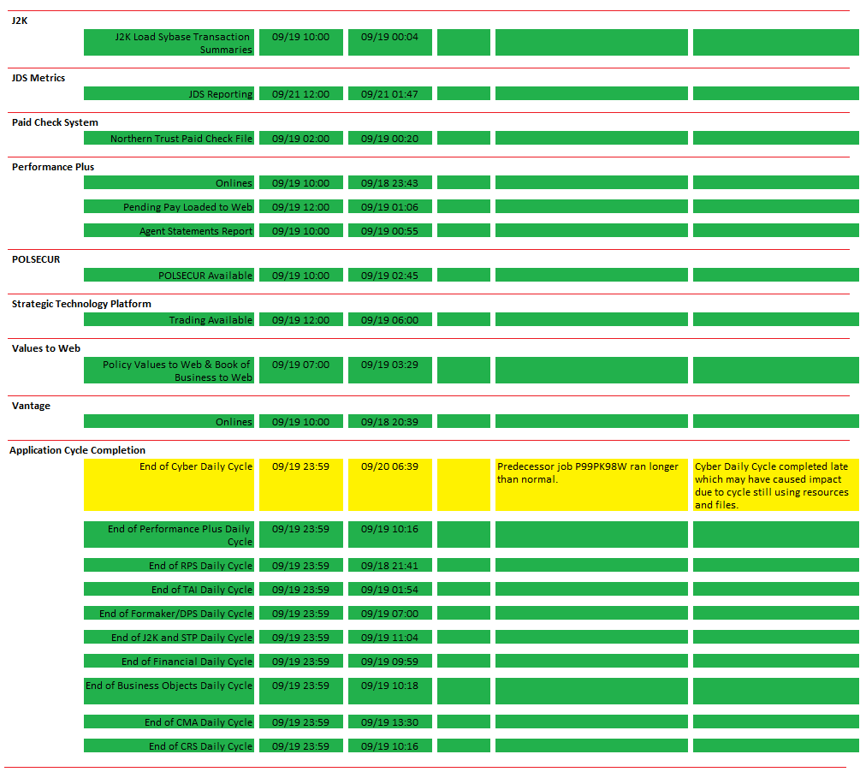

**Appendix B – Email Example**

Good Morning,

Please see below for today’s Cycle Status Report.  If you have any questions, please contact Service Level Management at ext. 22443 or ext. 23992.

This report is a point in time, where that time is the completion of each individual Service SLA for the indicated cycle date.  For those days in which any SLA is missed, updates will be reflected in this [Cycle Status Report Link](http://docs.jackson.local/it/sites/rs/Daily%20Reporting/2020/Cycle%20Status%20Report/05%20May/05202020%20Morning%20Cycle%20Report.pdf?d=wee1ace971dfe462b80018f85afdec619) on an hourly basis until all SLAs have completed.

Research may be done that could change/correct the details for any missed SLAs.  This changed/corrected detail information is available in the monthly SLA report which supersedes the data in the Cycle Status Report.

Cycle was released at 20:30.

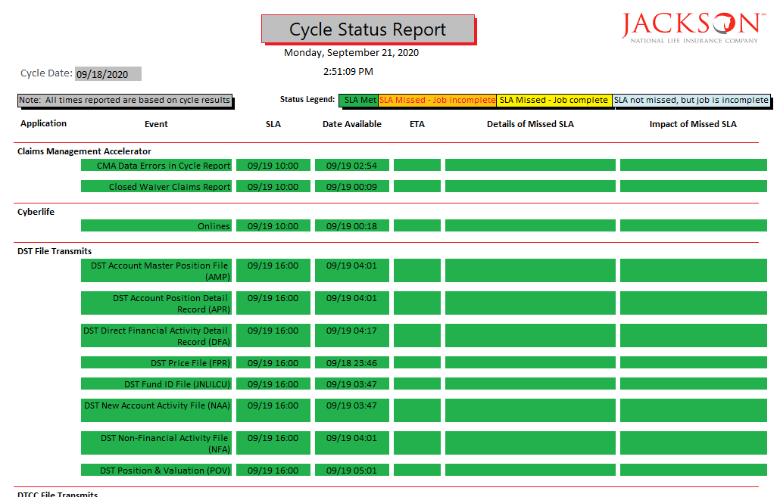

Cycle Completion reflects all processing has completed for each application/system listed for the indicated cycle date.   This does not represent any specific Service SLA but does include completion of all individual Service SLAs, backups, print jobs, and reorgs, etc.  When a cycle misses its SLA, impact assessment will be done to determine if further action is needed.

Because this encompasses the entire processing of cycle, the completion may occur late in the day, see the table below for the schedule of the days that will be reported in each Cycle Status Report email. Completion times for the most recent cycle date will be reflected in this

[Cycle Status Report Link](http://docs.jackson.local/it/sites/rs/Daily%20Reporting/2020/Cycle%20Status%20Report/05%20May/05202020%20Morning%20Cycle%20Report.pdf?d=wee1ace971dfe462b80018f85afdec619) on an hourly basis until all cycle processing has completed.

|  |  |
| --- | --- |
| **Reporting Day** | **Cycle Days being reported** |
| Monday | Prior Thursday and Friday |
| Tuesday | No cycle will be reported |
| Wednesday | Monday |
| Thursday | Tuesday |
| Friday | Wednesday |

05/19/2020 Cycle Completion

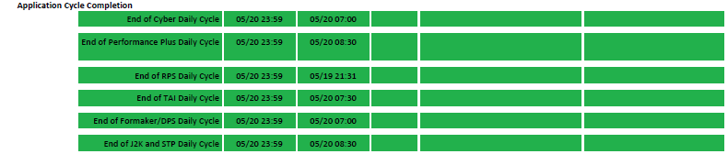

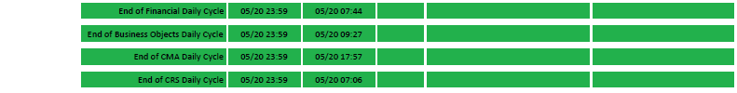

Thank You,

Service Level Management

**Appendix C – Fix report if colors are not displaying properly**

If the colors are not displaying properly for *jobs not completed* or *jobs completed but have missed their deadline*, follow the instructions below.

1. Open Design View for ***Job_Data_For_Date_Of_Cycle***.
2. The data type for *SLA_TS, END_TS*, and *Report_TS* must be set to “Date/Time”.

* The *End_TS* is sometimes switching to “Short Text”
* This is not being changed manually, but automatically behind the scenes

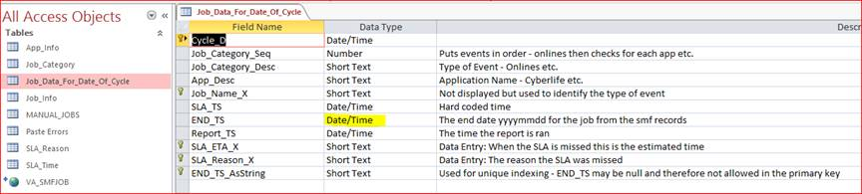

1. You may also have to update the “Report_TS” field for the entry that did not change color correctly. Make the time one minute less than the current time.



**Appendix D – Holiday Exceptions**

Jobs that order up on the cycle date before a holiday are expected to run as normal with the same SLAs, with the following exceptions:

**P99NFF7D – DTCC Day 2 Confirms (IFW)** – The **AM** run of this job will run on the next business day following the holiday.

**P99JX46D – DTCC Commissions (COM)** – This will run on the next business day following the holiday.

**Example:** If the job is ordered up for Monday’s cycle date and Tuesday is a holiday, the job will run on Wednesday. This is expected and stated in the Metric Data Definitions.

These jobs have exception SLA times on the holidays.

**P99NFXSD – DTCC Asset Pricing (AAP)**

Holidays: 9:00 PM (ET)

**P99NFXBD – DTCC Financial Activity (FAR)) (Priority 1)**

Holidays: 4:00 PM (ET)

**P99NFXCD – DTCC Financial Activity (FAR)) (Priority 2)**

Holidays: 4:00 PM (ET)

**P99NFXVD – Commission Schedule Transmittal (CST)**

Holidays: 6:00 PM (ET)

If any of these four jobs miss their SLA on the holiday, update the ***SLA_TS*** time in the Access Database.

**Example:** The normal SLA time for P99NFXSD is 6:00 AM. On the holiday the time would need to be manually updated to 21:00.





**P99DS45D – Northern Trust Paid Check File**

* Columbus Day (The Second Monday in October) and Veteran’s Day (November 11th).
* Northern Trust will not send a file on these two holidays. The job will still order up and will be Force Completed by the Data Center.
* There is no Miss or Carve-Out required.
* On the morning report, enter the following as the comment (no impact required).

*Northern Trust did not send a file due to the holiday. The job was Force Completed.*

**Modification**

The following associates can make modifications to this document:

* Manager, Service Level Management
* Director, IT Service Management
* Vice President, Service Delivery
* Chief Technology Officer, PGDS

|  |  |
| --- | --- |
| Service Level Management Process | |
| Responsible Party: Sharla Piepkow, Manager, Service Level Management Approving Authority: Rob Kolm, Director, IT Service Management | Date Created: 12/19/2012 Last Modified: 10/12/2020 Last Reviewed: |